**Media and Forms Assignment**

Solution:-

Q.1) Create an image gallery that holds multiple images.

Code:

<!DOCTYPE html>

<html lang="en">

<head>

    <meta charset="UTF-8">

    <meta http-equiv="X-UA-Compatible" content="IE=edge">

    <meta name="viewport" content="width=device-width, initial-scale=1.0">

    <title>3ass1q</title>

</head>

<body>

    <img src="https://images.unsplash.com/photo-1574169208507-84376144848b?w=500&auto=format&fit=crop&q=60&ixlib=rb-4.0.3&ixid=M3wxMjA3fDB8MHxzZWFyY2h8Nnx8aW1hZ2V8ZW58MHx8MHx8fDA%3D" alt="img1">

    <img src="https://images.unsplash.com/photo-1574169207511-e21a21c8075a?w=500&auto=format&fit=crop&q=60&ixlib=rb-4.0.3&ixid=M3wxMjA3fDB8MHxzZWFyY2h8MTJ8fGltYWdlfGVufDB8fDB8fHww" alt="img2">

    <img src="https://plus.unsplash.com/premium_photo-1682513184135-b7b9b76fb4eb?w=500&auto=format&fit=crop&q=60&ixlib=rb-4.0.3&ixid=M3wxMjA3fDB8MHxzZWFyY2h8MTd8fGltYWdlfGVufDB8fDB8fHww" alt="img3">

    <img src="https://images.unsplash.com/photo-1633621412960-6df85eff8c85?w=500&auto=format&fit=crop&q=60&ixlib=rb-4.0.3&ixid=M3wxMjA3fDB8MHxzZWFyY2h8MTR8fGltYWdlfGVufDB8fDB8fHww" alt="img4">

</body>

</html>

Output:

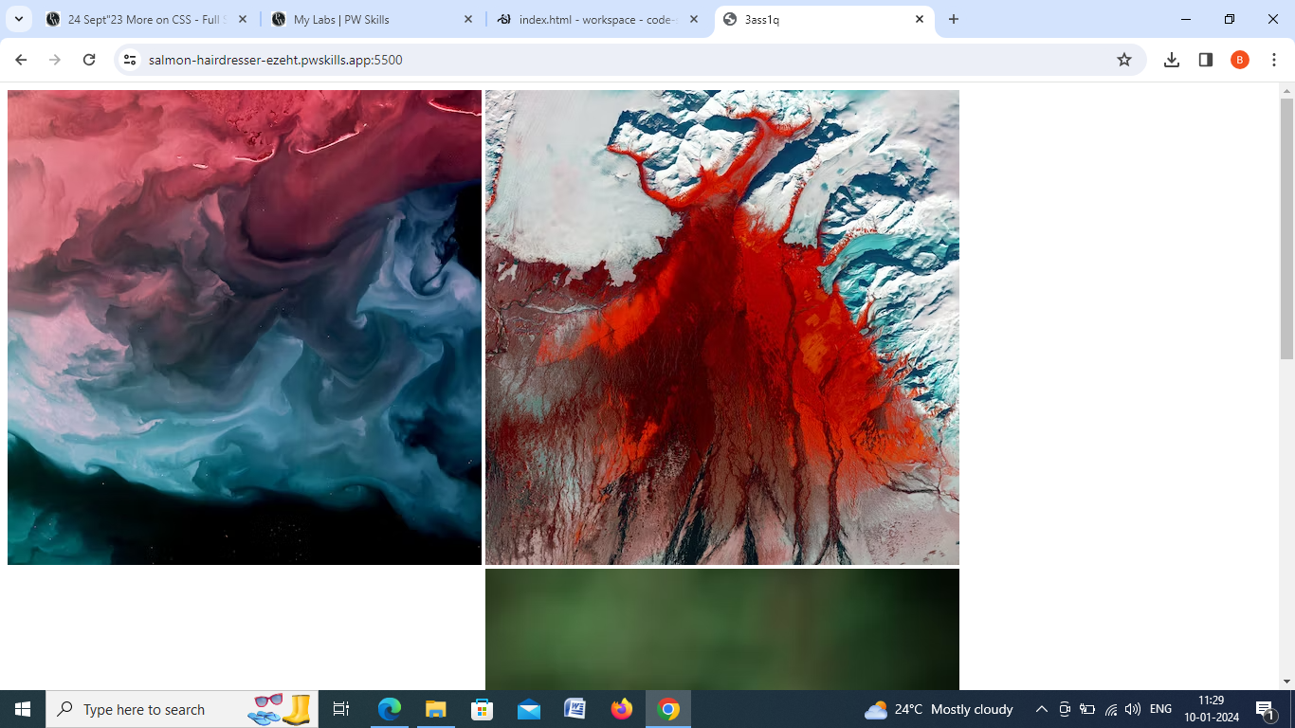

**Q2**) Use video and audio tags to display video and audio with the playback, audio controls.

Code:

<!DOCTYPE html>

<html lang="en">

<head>

    <meta charset="UTF-8">

    <meta http-equiv="X-UA-Compatible" content="IE=edge">

    <meta name="viewport" content="width=device-width, initial-scale=1.0">

    <title>3ass3q</title>

</head>

<body>

    <h1>The audio element</h1>

<p>Click on the play button to play a sound:</p>

<audio controls>

    <source src="simru.mp3" type="audio/ogg">

    <source src="simru.mp3" type="audio/mpeg">

  </audio>

  <h2>video tag</h2>

  <video  width="400" controls  poster="./diamond.png" >

    <source src="movie.mp4" type="video/mp4">

    <source src="movie.mp4" type="video/ogg">

  </video>

  <p>

  Video courtesy of

  <a href="./video song.mp4" target="_video sonng.mp4">Song</a>.

  </p>

</body>

</html>

Output:

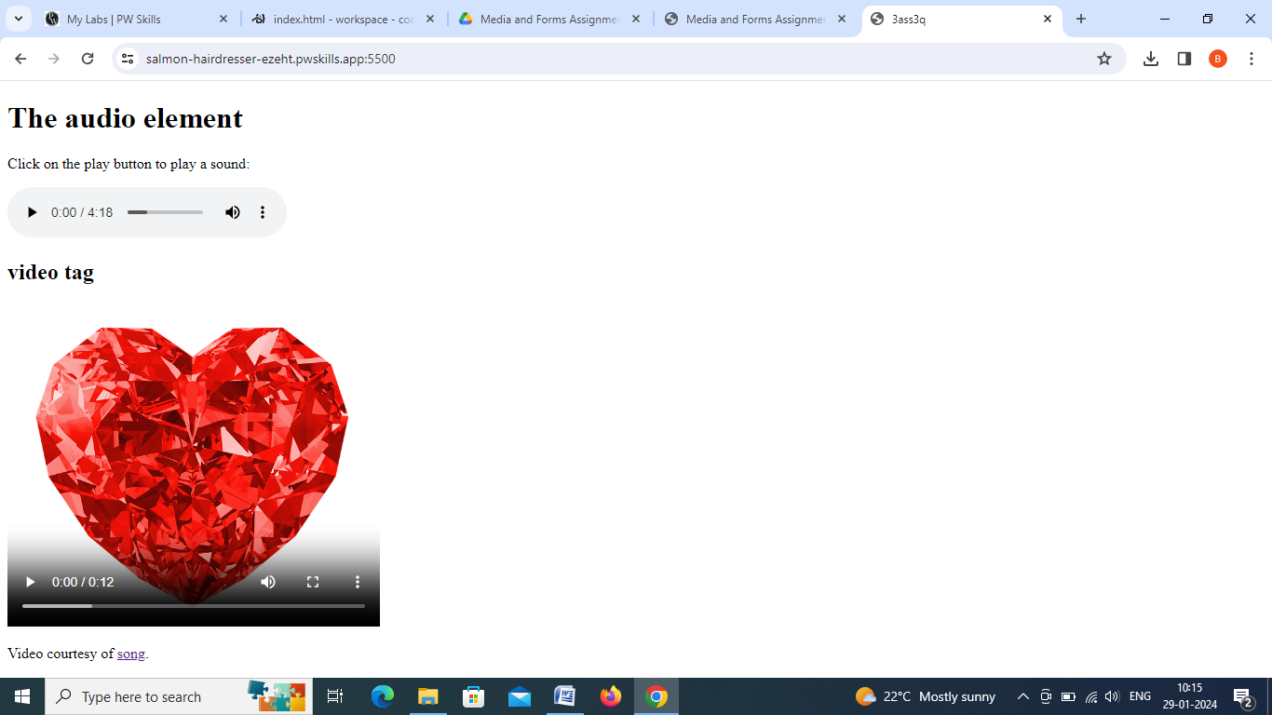

Q3)Modify the previous assignment so that the audio and video play automatically as the page is loaded and they should play infinitely.

Code:

<!DOCTYPE html>

<html lang="en">

<head>

    <meta charset="UTF-8">

    <meta http-equiv="X-UA-Compatible" content="IE=edge">

    <meta name="viewport" content="width=device-width, initial-scale=1.0">

    <title>3ass2q</title>

</head>

<body>

    <h1>The audio element</h1>

<p>Click on the play button to play a sound:</p>

<audio controls autoplay >

    <source src="simru.mp3" type="audio/ogg">

    <source src="simru.mp3" type="audio/mpeg">

  </audio>

  <h2>video tag</h2>

  <video width="400" poster="./diamond.png" controls autoplay>

    <source src="movie.mp4" type="video/mp4">

    <source src="movie.mp4" type="video/ogg">

  </video>

  <p>

  Video courtesy of

  <a href="./video song.mp4" target="_video sonng.mp4">song</a>.

  </p>

</body>

</html>

Output:

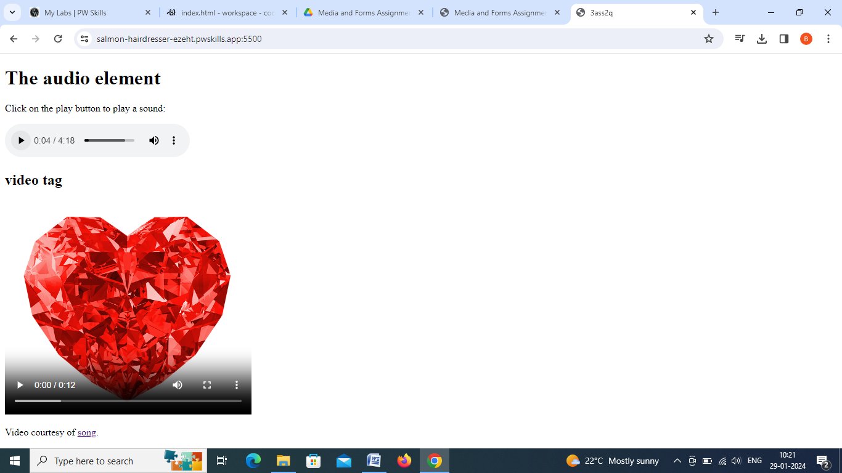

Q4)Use iframe to embed the physicswallah Wikipedia page properly.

Code:

<!DOCTYPE html>

<html lang="en">

<head>

    <meta charset="UTF-8">

    <meta http-equiv="X-UA-Compatible" content="IE=edge">

    <meta name="viewport" content="width=device-width, initial-scale=1.0">

    <title>3ass4q</title>

</head>

<body>

    <iframe src="https://en.wikipedia.org/wiki/Physics_Wallah" style="border:500" frameborder="5000" height="600" width="1200" ></iframe>

</body>

</html>

Output:

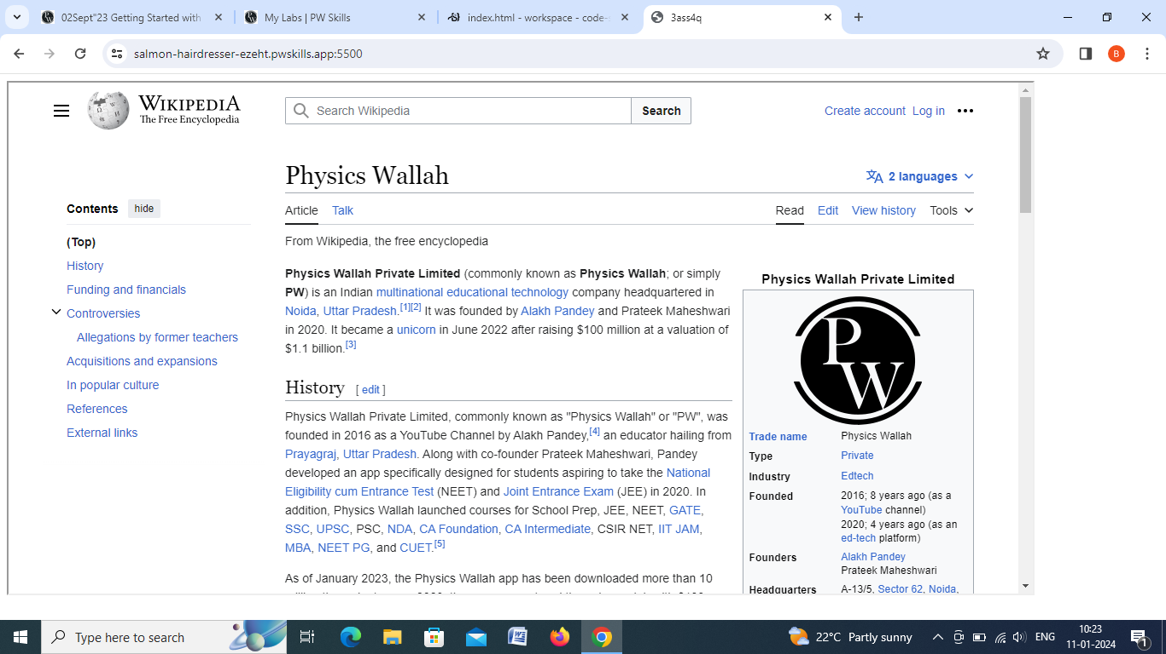

Q5)Create a sign-up and sign-in form with proper validation.

a.)Sign up form should have a first name ,last name,email,password,confirm password ,age,gender,and agree to terms and conditions fields at minimum(you can add other if you like).

b.)Sign in form should have email,password fields .

code:

<!DOCTYPE html>

<html lang="en">

<head>

    <meta charset="UTF-8">

    <meta http-equiv="X-UA-Compatible" content="IE=edge">

    <meta name="viewport" content="width=device-width, initial-scale=1.0">

    <title>3ass5q</title>

</head>

<body>

    <form action="./login.js" method="">

        <p><label for="first name">First name</label>

            <input placeholder="first name" type="text" name="first name" id="first name"  minlength="3" maxlength="5" required>

        </p>

        <p><label for="last name">Last name</label>

            <input placeholder="last name" type="text">

        </p>

        <p><label for="email">Email</label>

            <input placeholder="email" type="email" id="email" name="email" pattern="(?=.*\d)(?=.*[a-z])(?=.*[A-Z]).{3,}" title="Must contain at least one number and one uppercase and lowercase letter, and at least 3 or more characters" required>

        </p>

        <p><label for="password">Password</label>

            <input placeholder="password" type="password" id="psw" name="psw" pattern="(?=.*\d)(?=.*[a-z])(?=.*[A-Z]).{8,}" title="Must contain at least one number and one uppercase and lowercase letter, and at least 8 or more characters" required>

        </p>

        <p><label for="Confirm password">confirm password</label>

            <input placeholder="confirm password" type="password" id="psw" name="psw" pattern="(?=.*\d)(?=.*[a-z])(?=.*[A-Z]).{8,}" title="Must contain at least one number and one uppercase and lowercase letter, and at least 8 or more characters" required>

        </p>

        <p>

            <form action="/action_page.php">

                <label for="age">Age:</label>

                <input type="number" id="age" name="age" min="1" max="100">

              </form>

        </p>

        <p>

            <form>

                 Gender:<input type="radio" id="html" name="fav_language" value="male">

                 <label for="male">male</label>

                 <input type="radio" id="female" name="fav_language" value="female">

                 <label for="female">female</label>

                 <input type="radio" id="other" name="fav_language" value="other">

                 <label for="other">other</label>

                </form>

        </p>

        <form>

            Terms:<input type="checkbox" name="I agree to terms and coditions" id="">

            I agree to terms and coditions <br>

            <button type="submit">Register</button>

        </form>

        <div id="message">

          <h3>Password must contain the following:</h3>

          <p id="letter" class="invalid">A <b>lowercase</b> letter</p>

          <p id="capital" class="invalid">A <b>capital (uppercase)</b> letter</p>

          <p id="number" class="invalid">A <b>number</b></p>

          <p id="length" class="invalid">Minimum <b>8 characters</b></p>

        </div>

        <script>

            var myInput = document.getElementById("psw");

            var letter = document.getElementById("letter");

            var capital = document.getElementById("capital");

            var number = document.getElementById("number");

            var length = document.getElementById("length");

            // When the user clicks on the password field, show the message box

            myInput.onfocus = function() {

              document.getElementById("message").style.display = "block";

            }

            // When the user clicks outside of the password field, hide the message box

            myInput.onblur = function() {

              document.getElementById("message").style.display = "none";

            }

            // When the user starts to type something inside the password field

            myInput.onkeyup = function() {

              // Validate lowercase letters

              var lowerCaseLetters = /[a-z]/g;

              if(myInput.value.match(lowerCaseLetters)) {

                letter.classList.remove("invalid");

                letter.classList.add("valid");

              } else {

                letter.classList.remove("valid");

                letter.classList.add("invalid");

              }

              // Validate capital letters

              var upperCaseLetters = /[A-Z]/g;

              if(myInput.value.match(upperCaseLetters)) {

                capital.classList.remove("invalid");

                capital.classList.add("valid");

              } else {

                capital.classList.remove("valid");

                capital.classList.add("invalid");

              }

              // Validate numbers

              var numbers = /[0-9]/g;

              if(myInput.value.match(numbers)) {

                number.classList.remove("invalid");

                number.classList.add("valid");

              } else {

                number.classList.remove("valid");

                number.classList.add("invalid");

              }

              // Validate length

              if(myInput.value.length >= 8) {

                length.classList.remove("invalid");

                length.classList.add("valid");

              } else {

                length.classList.remove("valid");

                length.classList.add("invalid");

              }

            }

            </script>

    </form>

</body>

</html>

Output:

